Apply SQL JOIN

# Project description

The management at my organization has asked me to investigate potential security issues and update employee computers as required. As a Linux administrator, I used SQL with lters to perform security-related tasks. But for this scenario, I applied SQL join to play with the values of the two tables. This task is related to relational database management.

# Inner Join

I created a SQL query on MariaDB to join two tables focusing on the intersection of two tables, where we only care about rows that have corresponding values in both.

This is the “employees” table.

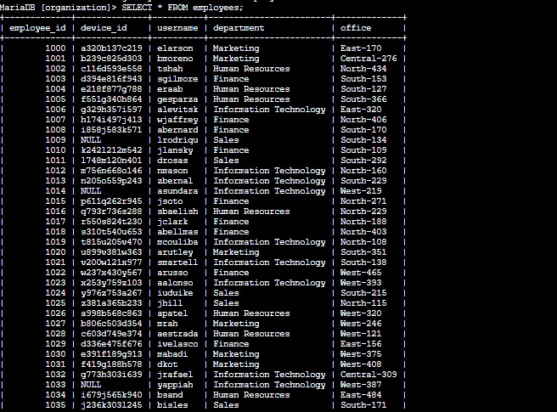

This is the “machines” table.

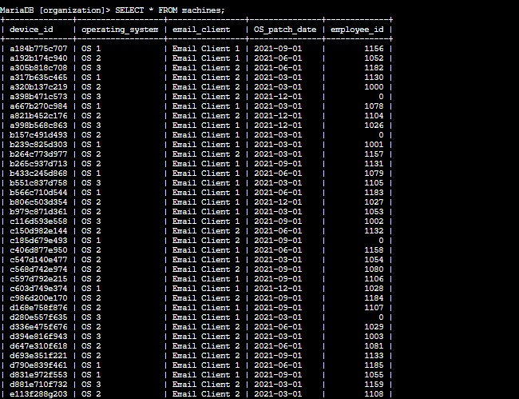

This is the query that produces username, operating system, and employee ID from both tables. The username is from one of the tables and so is the operating system. For the table that can be found on both, we use “table.column” format to avoid ambiquity. In this case it is the employee table (employee ID). As the result goes, there are 185 usernames with respective operating systems and device IDs. Other variations can be found in the next pages of Inner

Join.

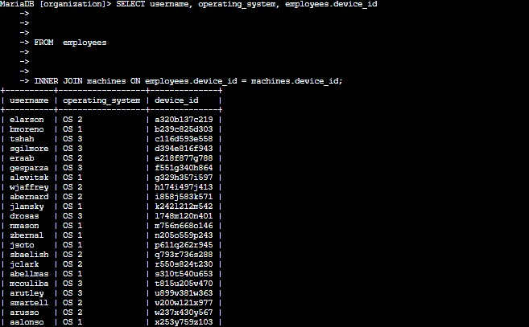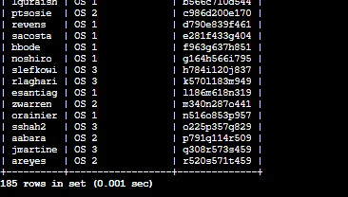

This query will produce username, employee ID, operating system, device ID and their respective o ce.

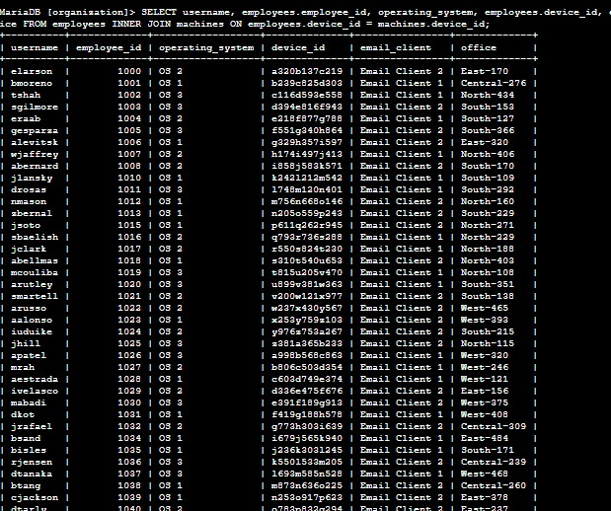

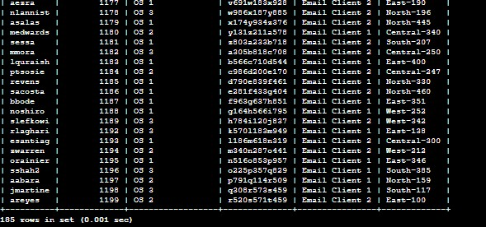

# Return More Data

Le Join. The results will include all records from one or the other table. Here, I have to link these tables using the common device_id column. In a le join, all records a er FROM and before LEFT JOIN are included in the result. In this case, all records from the machines table are included, whether they are assigned to the employees table or not.

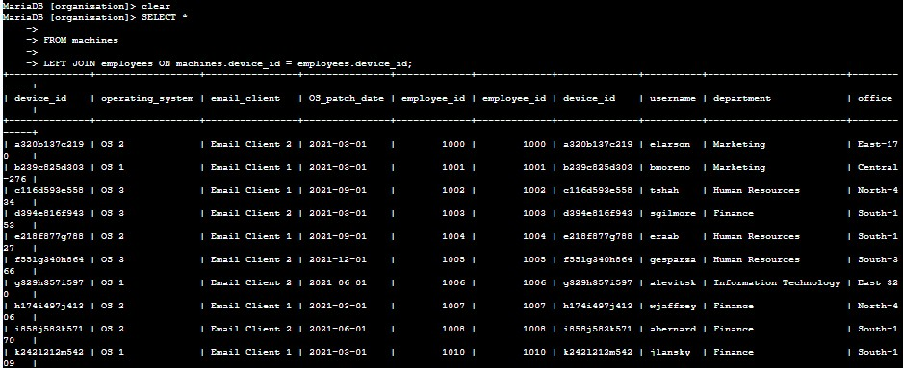

Right Join.

Right Join. The results will include all records from one or the other table. Here, I have to link these tables using the common device_id column. In a right join, all records a er RIGHT JOIN are included in the result. In this case, all records from the employees table are included, whether they have values on the machine table or not.

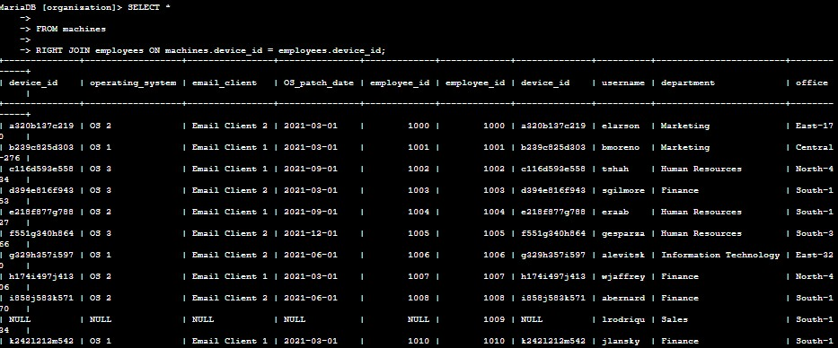

Both produced 200 rows each, however in the process, some data are wri en NUL due to types of JOIN.

# Summary

I wrote queries to join two tables in three di erent scenarios: Inner Join, Le Join, and Right

Join.